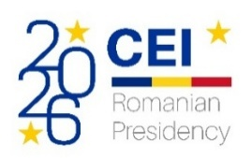 | 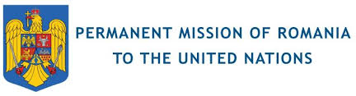 | 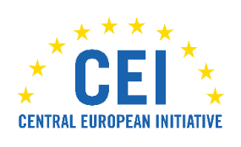
 | 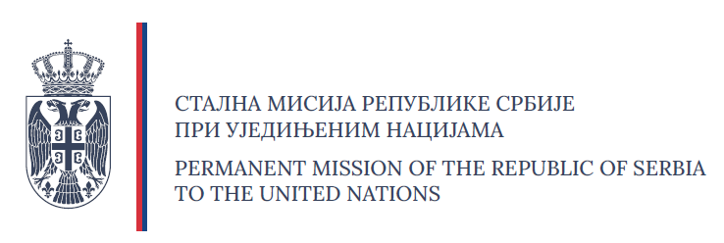 | 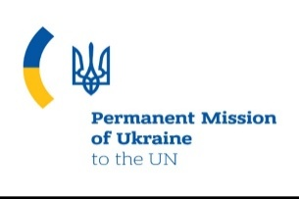
 | 
UN High-Level Political Forum 2026

Panel Discussion on “Sustainable Infrastructure in the CEI Region: Regional Cooperation as a Driver for SDG Implementation”

13 July, h. 1.15-2.30 pm UN Headquarters – New York, Conference Room 9

Programme

Opening
(Setting the Scene: Lidija ARSOVA, Responsible for External Relations, CEI-Executive Secretariat)

High-level Opening Statement
László BORBÉLY, State Counsellor to the Prime Minister of Romania and Head of Sustainable Development Department, CEI Presidency 2026

Addresses
Giorgio MARRAPODI, Ambassador, Permanent Representative of Italy to the UN
Radomir ILIĆ, Ambassador, Chargé d'affaires, Permanent Mission of the Republic of Serbia to the UN
Volodymyr PAVLICHENKO, Deputy Permanent Representative of Ukraine to the UN

Keynote Addresses
Jorge MOREIRA DA SILVA, UN Under-Secretary-General and UNOPS Executive Director
Ivana ŽIVKOVIĆ, UN Assistant Secretary General, UNDP Assistant Administrator and Director of the UNDP Regional Bureau for Europe and the CIS

Interactive Panel Discussion
(Moderator: Federico CASTIGLIONI, Researcher and Adjunct Professor, PhD, Istituto Affari Internazionali)

Introductory Remarks
Ivana PEJOVIĆ, CEI Deputy Secretary General

Strategic Perspectives
Gheorghe LEUCĂ, Permanent Representative of the Republic of Moldova to the UN
Miloš PRICA, Ambassador at Large, Co-chair of the Council for the Implementation of the SDGs of Bosnia and Herzegovina

From Strategy to Action: Regional Experiences and Best Practices
Vladimir KRKOBABIĆ, Manager for Traffic Affairs, Serbian Railways Infrastructure
Łukasz BIELEWSKI, Director of the Marshal’s Cabinet at the Marshal’s Office of Warmińsko-Mazurskie Voivodeship in Olsztyn, Poland

Interventions from the Floor and Q&A

Wrap-up by the Moderator

