 | 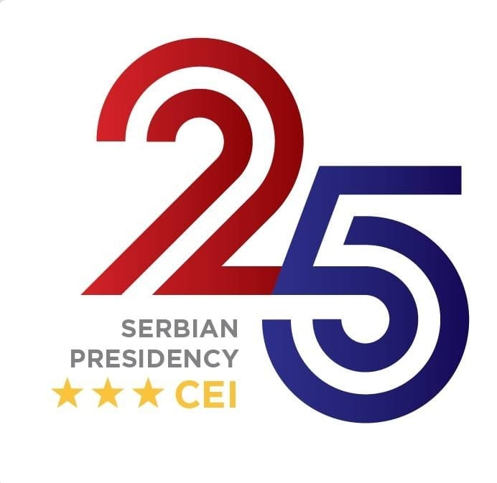 | 

CEI-TCT Panel:
“Integrated solutions for sustainable passenger and freight transport”
Niš (Serbia), 4 December 2025

Venue: Hotel Ambasador, Trg kralja Milana 4, Niš, Serbia -
https://maps.app.goo.gl/EeaUwmi3uTtdm1JD9

Draft agenda

Wednesday, 3 December 2025

20.00 Welcoming reception - hosted by CEI (venue: Hotel Ambassador)

Thursday, 4 December 2025

09:00 -10.00 Networking coffee

10.00-10.20 Opening remarks
- Milos Todorovic, Assistant Minister for the European Union, Ambassador, Ministry of Foreign Affairs of Serbia
- Matej Zakonjsek, Director, Transport Community Permanent Secretariat (on-line)
      - Zsuzsanna Kiraly, CEI Deputy Secretary General
      - Luca Gori, Ambassador of Italy to Serbia (video message)

10.20-10.30 Keynote addresses: Unlocking opportunities for regional connections
- High-level representative, Ministry of Construction, Transport and Infrastructure of Serbia

10.30-11.30 Session 1: Creating solutions for road crossing points’ bottlenecks and freight transport carriers
Session moderated by Mr. Mate Gjorgjievski, Transport Community Permanent Secretariat
- Nikola Veljovic, Assistant Minister, Ministry of Transport, Montenegro
- Eduart Kasa, President, Association of Albanian Enterprises for International Road Transport, ANALTIR, Albania
- Olivera Miovska, President, Best Mobility National Transport Association, North Macedonia
- Viliana Ivanova, Head of Department, Association of Bulgarian Enterprises for International Road Transport, Bulgaria
- Edna Karadza, Project Manager, CEFTA Secretariat
Q&A

11.30-12.00 Coffee break

12.00-13.00 Session 2: Challenges and perspectives offered by road and rail connectivity for cross-border and regional transport services
Session moderated by Mr. Carlo Fortuna, CEI-Executive Secretariat
- Nebjosa Jevtic, Senior Advisor, Chamber of Commerce and Industry of Serbia

- Mirko Vucinic, General Manager, Business Association of Road Transport Panotrasnport Novi Sad
- Giulietta Marinova, Ministry of Transport and Communications of Bulgaria
- Mirjana Vujicic, EBRD Resident Office in Serbia
- Matjaz Jancic, Head of Unit, Traveller and Carrier Support Operator, European Border and Coast Guard Agency (FRONTEX)
Q&A

13.00-14.30 Lunch - hosted by TCT Secretariat (Hotel Ambasador)

14.30-16.00 Session on road transport market liberalisation
Session moderated by Ms. Nerejda Hoxha, Transport Community Permanent Secretariat
- Ministries of Transport from the Western Balkans and Observing participants
- Chambers of Commerce and Road transport hauliers from the Western Balkans
- TCT, CEFTA, CEI
Discussion

16.00-16.15 Concluding remarks

19:30 Working dinner - hosted by TCT Secretariat and CEI (venue: Koste Stamenkovića 3, Niš, Serbia - https://maps.app.goo.gl/KbefvdthzPvLsc728)

