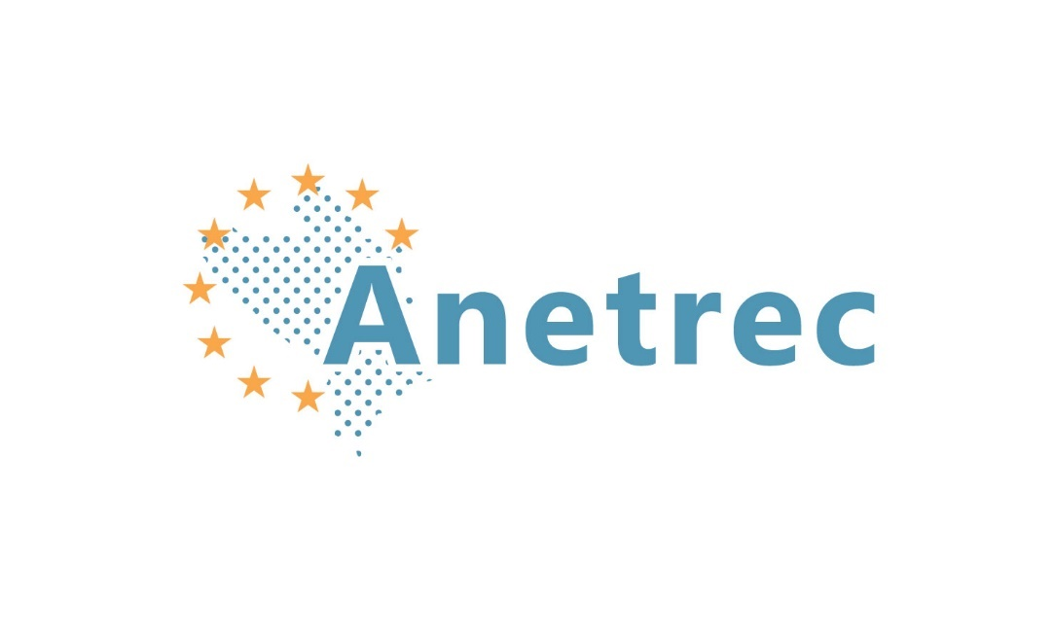www.anetrec.eu

ANETREC CONCLUDING CONFERECE

**EU POLICY TOWARDS WESTERN BALKANS WITH EMPHASIS ON REGIONAL COOPERATION, BASED ON RECONCILIATION – RESULTS AND CHALLENGES**

Maribor, 11-12 September 2023

Faculty of Law, University of Maribor, Mladinska ulica 9

**DRAFT PROGRAMME**

**Sunday, 10 September 2023**

Arrival of participants to Maribor and accommodation in Hotel Orel or BB hotel.

**Monday, 11 September 2023**

**9.30-10.00 Registration of participants**

**Chair:**

**Professor Emeritus Dr Silvo Devetak**, Coordinator of the ANETREC project, President of ISCOMET Institute, Maribor, Slovenia

**10.00-10.30 OPENING ADDRESSES**

- **Mr Oliver Varhelyi**, Commissioner, Neighbourhood and Enlargement, European

Commission, Brussels

**- Professor Dr Zdravko Kačič**, Rector, University of Maribor

- **Professor Dr Tomaž Keresteš**, Dean, Faculty of Law, University of Maribor

**I. CRITICAL ASSESSMENT OF THE EU POLICY TOWARDS WESTERN BALKANS IN THE CONTEXT OF THE PRESENT INTERNATIONAL POLITICAL AND SECURITY CIRCUMSTANCES**

**Chair: Professor Emeritus Dr Silvo Devetak**, Coordinator of the ANETREC project, President of ISCOMET Institute, Maribor, Slovenia

10.30-11.00 **Professor Emeritus Dr Silvo Devetak**, Coordinator of the ANETREC project, President of ISCOMET Institute, Maribor, Slovenia:

*The contribution of ANETREC project to the realisation of the EU policy towards the Western Balkans in the present entangled international circumstances*

11.00-11.20 **Dr Ezio Benedetti,** ISCOMET Institute for Ethnic and Regional Studies, Maribor, Slovenia:

*The current EU policy towards the Western Balkans – achievements and challenges*

11.20-11.40 **Assoc. Professor Dr Đana Luša**, **Assoc. Professor Dr Ružica Jakešević, Professor Dr Siniša Tatalović**, Faculty of Political Sciences, University of Zagreb, Croatia:

*Perspectives of EU enlargement to Western Balkans in changed security environment*

11.40-12.00 Coffee break

12.00-12.20 **Assoc. Professor Dr Elena Tilovska Kechegi,** Faculty of Law, University St. Kliment Ohridski, Bitola, North Macedonia:

*Importance of peaceful and stable WB for the security and stability of Europe in the current international circumstances*

12.20-12.40 **Nina Kodelja**, Deputy Secretary General of theCentral European Initiative, Trieste, Italy:

*Regional cooperation in the Western Balkans and Eastern Europe – the role and mandate of the Central European Initiative (CEI)*

12.40-13.40 Lunch

13.40-14.00 **Assoc. Professor Dr Goran Ilik**, Faculty of Law, University St. Kliment Ohridski, Bitola, North Macedonia:

*China’s influence in the WB: moving from economic interests with multilevel strategy towards multifaceted policies*

14.00-14.20 **Professor Mark Kramer**, Director, Cold War Studies, Harvard University, Cambridge, USA:

*The impact of the Russia-Ukraine war on the Western Balkans*

14.40-15.00 **Dr Ognjen Prebičević,** Former Ambassador of Serbia to Germany and UK, Head of the Centre for Politological Research and Public Opinion, Institute for Social Sciences, Belgrade, Serbia:

*Serbia and Western Balkan - between East and West after the War in Ukraine*

14.40-15.00 **Todor Lakić, M.A.** Faculty of Political Science, University of Montenegro, Podgorica, Montenegro:

*The subject of foreign, security and defence policy in the negotiations between Montenegro and Serbia with the European Union: perspectives and challenges*

15.00-15.20 **Professor Dr Sergei Glebov,** Odessa Mechnikov National University, Odessa, Ukraine:

*The role of “three seas cooperation” in the future European security and cooperation system*

15.20-15.40 Coffee break

15.40-16.00 **Assoc. Professor Dr Georgiana Ciceo**, Faculty of European Studies, Babeş-Bolyai University, Cluj-Napoca, Romania:

*The positive consequences and problems regarding the membership of Romania in the EU*

16.00-16.20 **Professor Dr Silviu Rogobete,** Honorary Professor, Stellenbosch University, South Africa, Director of Doctoral School of Philosophy, Sociology and Political Science West University of Timisoara, Romania:

*Romania and Western Balkans - viewpoints and dilemmas*

16.20-16.40 **Professor Dr** **Nadia Boyadjieva,** Faculty of Law, Plovdiv University, Plovdiv, Bulgaria**:**

*Achievements and dilemmas in the European integration process of Bulgaria*

16.40-17.00 **Professor Dr Gyöngyvér Hervainé Szabó,** Kodolanyi Janos University, Budapest, Hungary:

*The role of Western Balkans in the new European order- The view from Hungary*

17.00-17.20 **Professor Dr Simon János**, National University of Public Service, Editor-in-chief of CEPoliti Review, Budapest, Hungary:

*The necessity to spread information on the ANETREC project as an important event for the future of our region.*

**Tuesday, 12 September 2023**

**II. RESPECT OF OTHERNESS, HUMAN RIGHTS AND ELIMINATION OF DISCRIMINATION AS ONE OF PRECONDITIONS FOR STABILITY AND DEMOCRATIC PROGREE OF WESTERN BALKANS SOCIETIES AND A REGION AS A WHOLE**

**Chair**

**Assoc. Professor Dr Goran Ilik**, Faculty of Law, University St. Kliment Ohridski, Bitola, North Macedonia

9.30-9.50 **Prof. Dr Matjaž Tratnik,** ISCOMET Institute for Ethnic and Regional Studies, Maribor and Faculty of Law, University of Maribor, Slovenia:

*Nationality and discrimination in International and EU law*

9.50-10.10 **Professor Dr Goran Bašić,** Director, Institute for Social Sciences, Belgrade, Serbia:

*Multiculturalism in Western Balkans’ countries – situation and challenges*

10.10-10.30 **Professor Dr Iliriana Islami,** Faculty of Law, University of Prishtinë/Prishtina, Kosovo:

*Reconciliation and education in the Western Balkans*

10.30-10.50 **Professor Dr Remzije Istrefi,** Faculty of Law, University of Prishtinë/Prishtina, Kosovo:

*Peacebuilding and Education*

10.50-11.10 Coffee break

11.10-11.30 **Professor Dr Sonja Novak Lukanovič,** ISCOMET Institute for Ethnic and Regional Studies, Maribor and Institute for Ethnic Studies, Ljubljana, Slovenia:

*Respect of language diversity as a mean of stability and good neighbourhood relations of Western Balkans countries*

11.30-11.50 **Dr Marko Jovanović,** Institute for Social Sciences, Belgrade, Serbia:

*Multiculturalism and Islam in Europe and Western Balkans*

11.50-12.10 **Ass.** **Jan Stajnko, Ass. Melanija Lango**, ISCOMET Institute for Ethnic and Regional Studies, Maribor and Faculty of Law, University of Maribor, Slovenia:

*Ways and means in fighting hate speech in Western Balkans*

12.10-12.30 **Assoc. Professor Dr Oriona Muçollari,** **Assoc. Professor Dr Dorina Hoxha,** Faculty of Law, University of Tirana, Albania:

*The principle of equality and non-discrimination as a tool of creating stability and ensuring democratic development of Western Balkans countries as a precondition of accession to EU*

12.30-12.50 **Professor Dr Jernej Letnar Černič**, ISCOMET Institute for Ethnic and Regional Studies, Maribor and European Faculty of Law, New University, Ljubljana/Nova Gorica, Slovenia:

*Business and socio-economic rights: the situation in WB*

12.50-13.10 **Professor Dr Janja Hojnik,** ISCOMET Institute for Ethnic and Regional Studies, Maribor and Faculty of Law, University of Maribor, Slovenia:

*New EU Pact on Migration and Asylum – is Law Enough?”*

Lunch 13.10-14.10

14.10-14.30 **Professor Dr Sarina Bakić, Assoc. Professor Dr Mirza Emirhafizović,** Faculty of Political Sciences, University of Sarajevo, Bosnia and Herzegovina:

*The major challenges and opportunities involved in processes of settlement and integration of migrants into their new societies*

14.30-14.50  **Professor Dr Ivana Krstić**, Faculty of Law, University of Belgrade, Belgrade, Serbia:

*The prohibition of non-refoulement – the situation in Western Balkans*

*14.50-15.10* **Ass. Professor Dr Samir Forić**, Faculty of Political Sciences, University of Sarajevo, Bosnia and Herzegovina:

*Group identities and religion: politics, conflicts, and reconciliation in Western Balkans region*

*15.10-15.30* **Ass. Professor Dr Dalibor Djukić,** Faculty of Law, University of Belgrade, Belgrade, Serbia:

*Religion - State relations in the frame of reconciliation*

15.30-15.50**Assoc. Professor Dr Danijela Vuković-Ćalasan,** Faculty of Political Science, University of Montenegro, Podgorica, Montenegro:

*Ethno cultural diversity, minority rights and social cohesion in the process of EU integration of WB countries*

*15.50-16.20 Coffee break*

**III. CONSIDERING AND ADOPTING THE ANETREC DOCUMENTS CONCERNING THE EU POLICY TOWARDS THE WESTERN BALKANS**

**Chair**

**Professor Emeritus Dr Silvo Devetak,** Coordinator of the ANETREC project, President of ISCOMET Institute, Maribor, Slovenia

16. 20– 16.45 **Maribor declaration on supporting the regional cooperation in the Western Balkans based on reconciliation with emphasis on Serbia-Kosovo reconciliation process**

**Reporters:** **Professor Dr Iliriana Islami**, Faculty of Law, University of Prishtinë/Prishtina, Kosovo, **Professor Dr Goran Bašić,** Institute for Social Sciences, Belgrade, Serbia and **Dr Ezio Benedetti,** ISCOMET Institute for Ethnic and Regional Studies, Maribor, Slovenia

16.45 – 17.10 **Segregation in education in Bosnia and Herzegovina as an obstacle to the development of a stable multicultural society**

Reporter: **Professor Dr Sarina Bakić,** Faculty of Political Sciences, University of Sarajevo, Bosnia and Herzegovina

17.10 - 17.20 **Proposal for establishing the EU reference centre for Western Balkans**

17.20 **CONCLUSION OF THE ANETREC CONFERENCE**

**Wednesday, 13 September 2023**

Departure of participants from Maribor.

**ANETREC CONCLUDING CONFERENCE PROGRAMME COMMITTEE**

Professor Emeritus Dr Silvo Devetak

ANETREC Summer School coordinator and ISCOMET Institute

iscomet@siol.net

+38641699641

Franc Mlinar, MA, Secretary of the Program committee

ISCOMET Institute

franc.mlinar@ecers-um.si

+38641373199

Assoc. Professor Dr Oriona Muçollari

Faculty of Law, University of Tirana

tildamia@yahoo.it

Assoc. Professor Dr Sarina Bakić

Faculty of Political Sciences, University of Sarajevo

sarina.bakic@fpn.unsa.ba, sarinabakic@hotmail.com

Assoc. Professor Dr Đana Luša

Faculty of Political Science, University of Zagreb

dana.lusa@fpzg.hr

Assoc. Professor Dr Elena Tilovska-Kechedji

University St. Kliment Ohridski, Bitola

elena.tilovska-kechegi@uklo.edu.mk

Professor Dr Iliriana Islami

Faculty of Law, University of Prishtinë/Prishtina

Ilirianaislami@yahoo.com

Assoc. Professor Dr Danijela Vuković-Ćalasan

Faculty of Political Science University of Montenegro

danijelacalasan@gmail.com

Professor Dr Dragica Vujadinović

Faculty of Law, University of Belgrade

dragicav@ius.bg.ac.rs

Dr Goran Bašić

Institute of Social Sciences

basicgoran11@gmail.com

Professor Dr Matjaž Tratnik

Faculty of Law, University of Maribor

matjaz.tratnik@um.si