PRESS RELEASE

LESSONS FOR A SUCCESSFUL LIFE
FOR 10,000 UKRAINIAN CHILDREN IN POLAND

On the basis of the Ukrainian Education Hub in Poland, which provides free educational services for Ukrainian refugees in connection with the war in Ukraine, launched a large-scale social project "Lessons of a successful life" for Ukrainian students aged 11-16 with the support of the United Nations Children's Fund (UNICEF), the Ministry of Education and Science of Ukraine, the Ministry of Education and Science of Poland, Warsaw City Hall, Pro Futuro Foundation and the Association of Innovative and Digital Education.
Within 8 months, more than 10,000 Ukrainian teenagers who are currently in Poland will receive practical skills in financial and computer literacy, career guidance, emotional intelligence, communication, time management and other soft skills, which international experts of the World Forum in Davos recognized as skills of 21st century.
In addition to students, Ukrainian teachers are also being trained as part of this project - they learn the Polish language and acquire useful soft skills.
Also, the Ukrainian Education Hub in Poland is open to Ukrainian schoolchildren and is ready to provide effective education daily for up to 30 children at the same time according to the official school program of Ukraine, and also provides other useful services, such as career guidance, workshops and pleasant communication among new friends, etc.
Recently, a solemn presentation of this project took place in the premises of the Ukrainian Education Hub in Poland (77/79 Marszałkowska St., Warsaw).
The event was attended by representatives of governmental organizations of Poland and Ukraine, international institutions, and donor organizations - partners of the Ukrainian Education Hub in Poland.
Andrii Vitrenko, First Deputy Minister of Education and Science of Ukraine noted: "It is very important that Ukrainian schoolchildren, who were forced to find themselves abroad, should be able to continue their studies according to the Ukrainian official program if they wish. We are also launching a systematic training for Ukrainian students of 6-11 grades in useful skills to become successful in the modern world - "Lessons for life", and we will also help determine the profession of their dreams and build their own trajectory of further education and career. The first stage should cover 10,000 students."
Vitalii Bilyi, First Counselor of the Ambassador of Ukraine to Poland said: "Children who study in schools today will rebuild Ukraine tomorrow, so it is very important today to have modern skills and to bring to Ukraine both knowledge and technology and the level of culture and respect in society, which are currently inherent in developed European countries, to which Poland rightfully belongs".

Karolina Zdrodowska, Head Coordinator for Entrepreneurship and Social Dialogue of the City Hall of Warsaw said: "The Ukrainian Education Hub in Poland is an important component of work with Ukrainian citizens in Poland, especially in the area of preparation for employment, development of entrepreneurial skills, and the City Hall of Warsaw will continue to provide comprehensive assistance in the development of this project."

Francesco Calcagno, Chief of Education at the UNICEF Emergency Response Office in Poland, emphasized: "We know that the war in Ukraine, unfortunately, affected children. However, we believe that the activities provided by the Ukrainian Education Hub in Poland will help children achieve success in life. On behalf of UNICEF, we would like to thank everyone for their willingness to help Ukrainian children who are currently in Poland because of the war."

Iryna Ivanyuk, an employee of the Department of Education of the City Hall of Warsaw, as well as representatives of Ukrainian schools in Warsaw ("Materynka" and "Talent" Creativity Center) also congratulated the participants and emphasized the importance of educating teenagers, who today most of all lack social contacts and friends in another country.

Anna Adamczyk, Project Manager of the International Visegrad Fund, and Barbara Fabro, Senior Executive Director of the Central European Initiative, spoke about the support of the Ukrainian Education Hub in Poland in working with adult Ukrainians to ensure their rapid adaptation in Poland, namely: language training, relevant IT professions, preparation for employment and first psychological aid.

Mariya Boguslav, Executive director of the Association of Innovative and Digital Education, Head of the "Education Hub for Ukrainian Children and Teachers" project, spoke about the main services that Ukrainian schoolchildren and teachers can currently receive until the end of June 2023, namely:
- free access to distance learning platforms for all students of grades 1-11 in order to continue their studies according to the Ukrainian program, online or physically in the premises of the Ukrainian Education Hub in Poland,
- participation of Ukrainian students of grades 6-11 in "Lessons for a successful life" on the basis of Ukrainian or Polish schools in various cities of Poland,
- training of Ukrainian teachers on the basis of the Ukrainian Educational Hub in Poland in the Polish language, as well as training in useful skills of the 21st century online throughout Poland,
- career guidance services, online remote kindergarten, training of teachers in career guidance and providing psychological first aid and many other useful services.

More information about all services can be found on the website of Ukrainian Education Hub in Poland or subscribe to the telegram channel https://t.me/UAeduhubPL. All services are free of charge.

The Ukrainian Education Hub in Poland is part of the network of Ukrainian Education Hubs (an official project of the Ministry of Education and Science of Ukraine, which is one of the top priority projects of the Government in the field of education during the war), which already includes 16 Hubs, both in Ukraine and in Europe (Poland, Germany, Great Britain, Switzerland, Hungary, Czech Republic, Slovakia, Bulgaria).

The project "Lessons for a successful life" is implemented with the support of the United Nations Children's Fund (UNICEF).

For detailed information, you can contact the project coordinators (contacts are available on the website: https://poland.eduhub.org.ua)

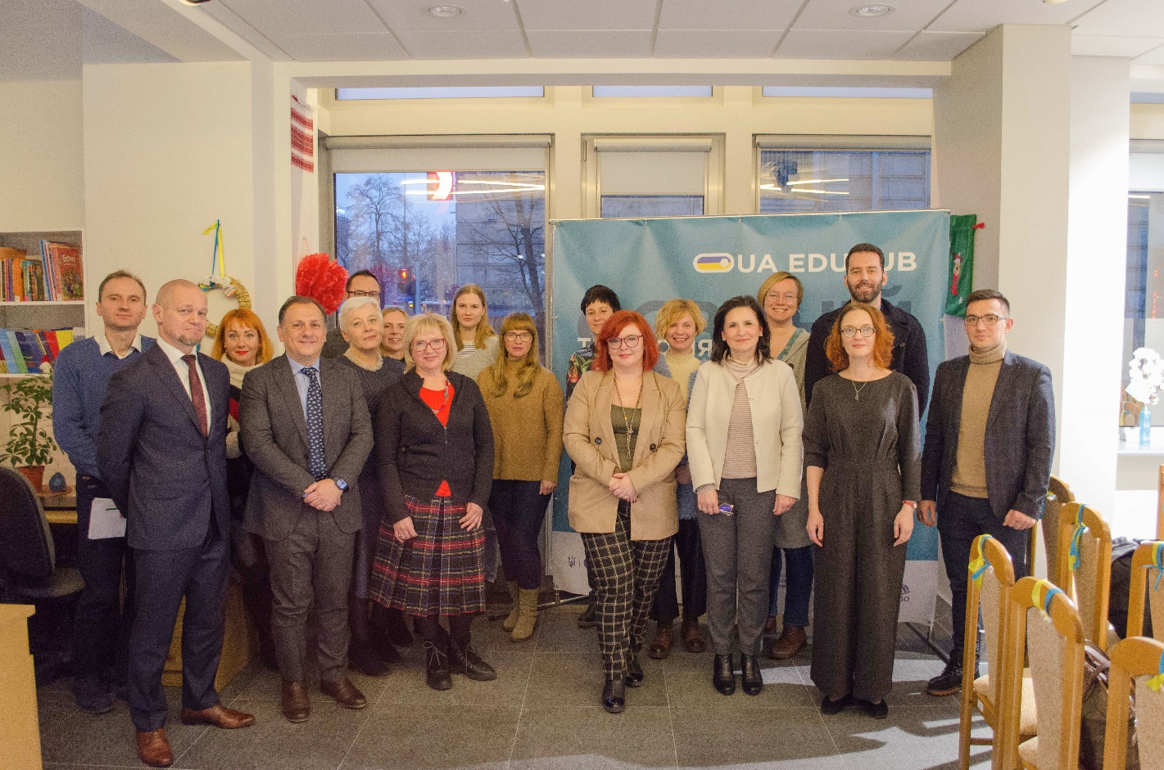

This and other photos from the event are available at the link: https://drive.google.com/drive/u/0/folders/1kyZrpA8GSQeefOFxfpxwWyYsQQvZNi0a

