**Social Enterprise Transnational Advocacy Network**

**(SETAN)**

**Webinar “Social enterprises and COVID-19”**

10 November 2020

10.00 – 11.00 am

***To register and to receive the link for participating in the webinar send an email to: euprojects@cei.int***

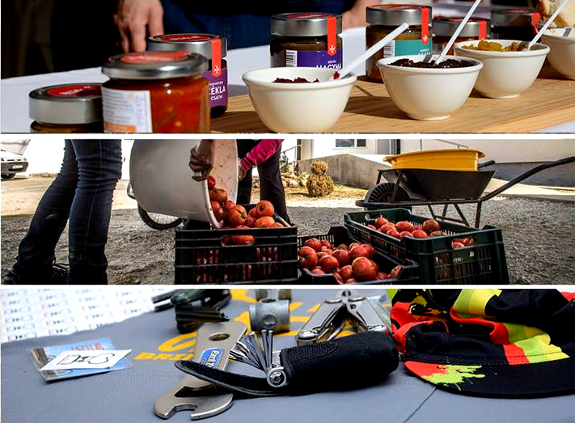

**Introduction to SETAN**

The Social Enterprise Transnational Advocacy Network (SETAN) has been established in the framework of an INTERREG Central Europe project called SENTINEL by different organizations coming from 6 countries that shared the idea that social economy and social enterprises are crucial for the convergence of disadvantaged regions of Central Europe. **SETAN aims at promoting and strengthening social enterprises’ vision and role in an effective manner in order to influence policies, programs and initiatives** and this will be done by improving knowledge and increasing awareness among governments, policy makers, EU officials, local communities, and other entities such as funding agencies, on issues affecting SEs.

**Social Enterprises and Covid-19**

The Covid-19 health crisis gravely impacted social enterprises: loss of income and shortage of staff are only two of the significant challenges they are facing. Many have managed to adapt to the current situation; however, social enterprises are at risk of collapsing without proper support and understanding from public administrations. Moreover, the crisis affected people’s lives insubstantially different ways and to varying degrees— highlighting underlying structural inequalities across the globe. Despite the difficult situation, social enterprises are assigning the recovery from the crisis by providing innovative solutions and strengthening public services to complement government action. The activity of social enterprises has repeatedly proven to be capable of identifying and implementing alternative solutions to expand social innovation and social economy. This emergency has demonstrated the urgent need to rethink our economy. Thus, during and after the crisis, social enterprises— in addition to their traditional purpose—can develop a much larger role, inspiring transformation, increasing efficiency and resilience throughout the socioeconomic framework.

**Purpose of the Webinar**

The objective of the webinar “**Social enterprises and COVID-19**” is to provide information on the range and depth of the impact of the Covid19 health crisis on social enterprises. The public event will open with a brief presentation of the network’s activities followed by three main speeches focused on different aspects of social entrepreneurship and illustrating specific experiences and examples. In the midst of the current health emergency, these contributions from experts aims at highlighting the numerous challenges affecting the very survival of social enterprises, ranging from accessibility to funding and support to protecting additionally damaged individuals from vulnerable groups.

### **Agenda**

10:00 – 10:10 Welcome and Presentation of the SETAN

**Gian Matteo Apuzzo**(Central European Initiative-Executive Secretariat)

10:10 – 10:25 Impact of Covid-19 on social enterprises: overview and policy implications

**Suzanne Wisse-Huiskes** (EUCLID Network)

10:25 – 10:35 Social enterprises and social inclusion in the Covid-19 pandemic

**Jelena Ankic** (SOCIETIES Project,Caritas Serbia)

10:35 – 10:45 Social enterprises support services in response to Covid-19

**Stefan Chichevaliev** (Social Entrepreneurship Observatory, Skopje)

10:45 – 11:00 Discussion and conclusions

**References**

*Social Enterprise and COVID-19*, Social Enterprise UK (2020) <https://www.socialenterprise.org.uk/wp-content/uploads/2020/05/Social-Enterprise-COVID-19-research-report-2020.pdf>

*The Impact of Covid-19 on Social Economy Enterprises*, Social Economy Europe (2020) <https://www.socialeconomy.eu.org/wp-content/uploads/2020/06/SEE-Report-The-impact-of-COVID-19-on-Social-Economy.pdf>

*Social economy and the COVID-19 crisis: current and future roles*, OECD (2020) <http://www.oecd.org/coronavirus/policy-responses/social-economy-and-the-covid-19-crisis-current-and-future-roles-f904b89f/>