 |  | 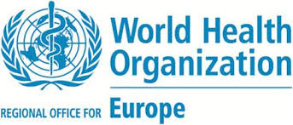
6th Meeting of the
CEI-WHO Task Force in response to COVID-19 emergency
9 September 2020 (10.00 a.m. – 12.00 p.m.)

Draft Agenda

10:00 – 10:10

1. Adoption of the Agenda

2. Adoption of the Minutes of the Fifth Meeting of the CEI-WHO Task Force in response to COVID-19 emergency (8 July 2020)

10:10 – 10:30

3. Information on the work plan until December 2020 of the CEI-WHO Task Force in response to COVID-19 emergency

10:30 – 11:50

4. Thematic session: Safe school reopening. Measures for safe school reopening: activities, emerging evidence and good practices
- WHO presentation: Martin Willi Weber , Program Manager EU/RGO/DNP/CAH
- Presentations by Member Countries
- Discussions

11:50 – 12:00

5. Any other business

