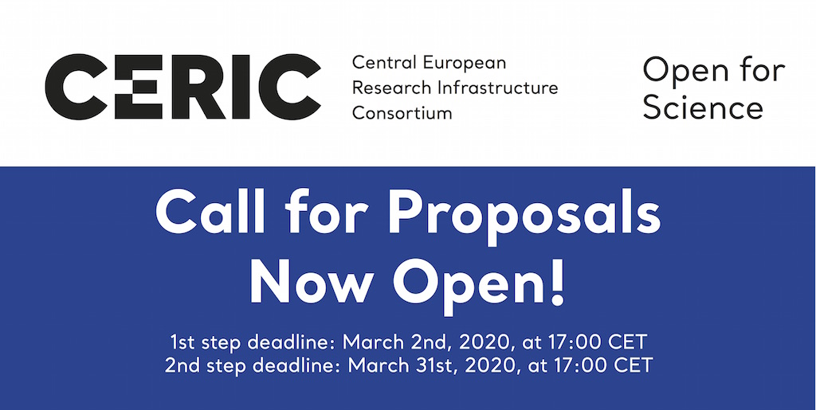
CERIC-ERIC is calling for proposals! Submit yours here: https://vuo.elettra.trieste.it/
CERIC-ERIC, Central European Research Infrastructure Consortium, offers access to more than 50 complementary instruments and two support laboratories, for multidisciplinary research in all fields of materials, biomaterials and nanotechnology.
Researchers from all over the world can apply for access free of charge, upon the condition that results are published and CERIC acknowledged.
CERIC also offers support for mobility of two users per proposal and awards for high-quality open access publications.
As usual, there will be two deadlines in this call:
- March 2nd, 17hs CET, to have a pre-evaluation and the possibility to improve your proposal.
- March 31st, 17hs CET, recommended only for expert users of all the techniques requested.

Check the Open Access offer for this semester at this link.

CERIC now accepts single instrument proposals for all CERIC instruments and beamlines at the Budapest Neutron Centre and Solaris.

Due to technical upgrades at the Slovenian facility, limited time will be offered on the NMR spectrometers.
For further information about the call, visit https://www.ceric-eric.eu/users/call-for-proposals/ or contact us at useroffice@ceric-eric.eu
If you are a researcher working in Albania, Belarus, Bosnia & Herzegovina, Bulgaria, Estonia, North Macedonia, Latvia, Lithuania, Montenegro, Moldova, Romania, Russia, Serbia, Slovakia or Ukraine, apply for promotional open access: in the frame of the European H2020 project ACCELERATE, personalized support for proposal preparation, measurements and data analysis can be provided upon request.

