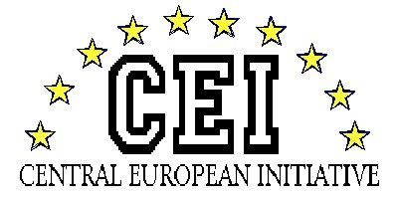
HUNGARIAN NATIONAL ASSEMBLY Session of the CEI-PD Parliamentary Committee
28-30 March 2019, Budapest

CONCLUSIONS of the meeting of the CEI PD GENERAL COMMITTEE ON CULTURAL AFFAIRS on the

“New perspectives of cultural cooperation”

held on 29 March 2019 in Budapest, Hungary

The participants of the CEI PD General Committee on Cultural Affairs held discussions on the topic of the meeting and arrived at common understanding on:

- The comprehensive objective of tourism policy is to stimulate the competitiveness of the economy on a sustainable manner and at the same time in order to become a modern and responsible policy-sector, which can preserve natural and environmental values for future generations in the countries of CEI.

- The tourism is such a determining strategic sector, which can provide a positive impact on the whole economy, can improve the competitiveness and employment, and it has proved to be a strong incentive for investments.

- We agree on the objective that the cross-border tourism should create a higher added value in the participating countries helping to achieve an increase of their GDP. Due to the cross-border characteristics of landscapes with many attractions and destinations, joint and coordinated approach and creation of joint tourist products is needed. Through the development of cross-border tourism we must help to improve cooperation as well as contribution for our region to become Europe’s leading touristic destination. Tourism activities are often important first steps in improving the sense of social cohesion along the borders resulting in additional positive effects on cross-border cooperation culture.

- Great touristic potential should be turned into competitive tourist products that will enrich the tourism offer in touristic destinations. We have to pay special attention to the development of touristic regions and promote their sustainable development.

- Establishing such a legislative environment and related system of organisations, which allow the elaboration of individual guidelines for the certain destinations, is essential.

- Destinations with unique characteristics should create or promote their self-supporting brands, and synthesis of different brand-profiles. From this point of view the pilgrim tourism is a complex issue, which requires further cooperation amongst each other.

- The development of destinations can be reached by the following methods: creating the different elements of supply in the form of touristic package; the improvement of destinations’ draw in terms of increasing its competitiveness, assortments and standards; education of all stakeholders at the local community level.

- A long-term innovation strategy should be set up in the countries of CEI for the tourism’ development in response to challenges of the digital era.

