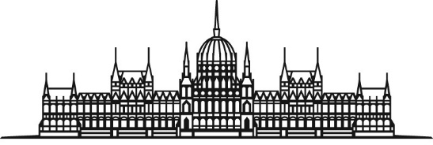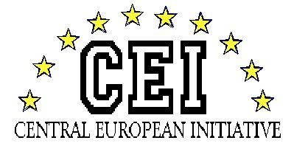
HUNGARIAN NATIONAL ASSEMBLY Session of the CEI-PD Parliamentary Committee
28-30 March 2019, Budapest

Press Article to the website of CEI PD

The meeting of the General Committee on Cultural Affairs of the Central European Initiative Parliamentary Dimension was held on 28-30 March 2019 in Budapest in the building of the Hungarian National Assembly and in Sárospatak. Mr Richárd Hörcsik, Chairman of the Committee on European Affairs of the Hungarian National Assembly and Head of the Hungarian Delegation to the CEI PD chaired the event. Parliamentary delegations from nine countries and 3 additional embassies of CEI countries participated in the consultation. Ms. Márta Mátrai, the Deputy of the Speaker and Mr Antal Nikoletti delivered the opening speech.

The aim of the Hungarian Chairmanship in the Cultural Committee for the period 2018-2019 is to place great emphasis on promoting intercultural cooperation through constructive dialogue and cultural exchange and to strengthen the active role of CEI PD.
The CEI PD Cultural Committee put on agenda at its meeting in Budapest the new perspectives of tourism, focusing on two important issues: the cross-border tourism and the special role of pilgrim tourism.
In the adopted conclusions of the meeting the parliamentarians set out that ”tourism is such a determining strategic sector, which can provide a positive influence on the whole economy”. It was emphasised that during the implementation of common actions the countries of CEI had to assist each other through any form of cross-border tourism to reach stronger economic growth and a multiplied positive impact. According to the conclusions through the development of cross-border tourism, the CEI countries should help to improve cooperation as well as contribution for the region to become Europe’s leading touristic destination. It was concluded that tourism activities were often important first steps in improving the sense of social cohesion along the borders resulting in additional positive effects on cross-border cooperation culture.

Following the official part of the meeting a cultural event was organised for the participants in Sárospatak.

Attachments: Conclusions; Family Photo

