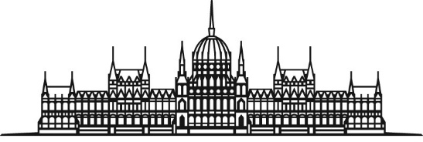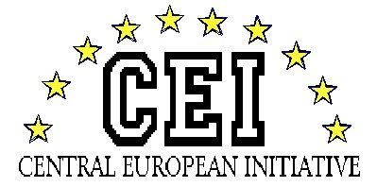
HUNGARIAN NATIONAL ASSEMBLY Session of the CEI-PD Parliamentary Committee
28-30 March 2019, Budapest

DRAFT PROGRAMME

Meeting of the General Committee on Cultural Affairs:
“New perspective of cultural cooperation”
Budapest, 28-30 March 2019

Thursday, 28 March 2019

Arrival of delegations to the Hotel President Budapest
Budapest, 1054 Budapest, Hold u. 3-5.

17.30 Departure from the Hotel to the venue of the reception by bus

18.00 Welcome reception hosted by Mr. Richárd HÖRCSIK, Head of the Hungarian Delegation of the PD CEI
Venue: tbc
Friday, 29 March 2019

8.30 Departure by bus from the Hotel to the Parliament

09.00 Registration of participants

9.30 Opening of the CEI-PD Committee Meeting
Venue: Delegation Hall of the Parliament

Welcome address of the Deputy Speaker of the Hungarian National Assembly (tbc)
9.45 Adoption of the draft agenda

Introductory remarks of Mr. HÖRCSIK Richárd, Head of Hungarian Delegation of the PD CEI (tbc)

10.00 Discussion on Cross Border Tourism development programmes and their perspectives within CEI countries (tbc)

Keynote speaker 1: tbc
Keynote speaker 2: tbc

Debate

11.30 Family photo and coffee break
Venue: Room 38, Main floor

11. 45 Discussion on the new cultural-touristic thematic: the pilgrim routes in CEI countries (tbc)

Keynote speaker 1: tbc
Keynote speaker 2: tbc

Debate

12.30 Debate and adoption of the Common Statement

Closure of the Meeting

13.00 Buffet lunch
Venue: Gobelin Hall
14.30 Guided tour in the Parliament (optional)

15.00 Departure to Sárospatak by bus (optional)

18.30 Arrival to the Hotel
Venue: Hotel Bodrog
3950 Sárospatak, Rákóczi út 58.

19.15 Departure from the Hotel to Tokaj Portius Winery (by bus) (tbc)

19.30 Dinner and wine tasting hosted by Mr. HÖRCSIK Richárd, Head of the Hungarian Delegation to the CEI–PD
Venue: Tokaj Portius Winery, Hercegkút
22.00 Return to Hotel Bodrog (by bus)
Saturday, 30 March 2019

8.45 Departure from the Hotel to the cultural programme (by bus)

09.00 Cultural programme (tbc)
Guided tour at the Rákóczi Castle

10.00 Departure to Hollóháza (by bus)

11.00 Arrival to Hollóháza Museum
Visit of the museum

12.15 Departure to Telkibánya

12.45 Lunch and pálinka tasting hosted by (tbc)
Venue: Tbc

14.15 Departure to Budapest

17.00 Arrival to Budapest
Individual Departures of the Delegations

