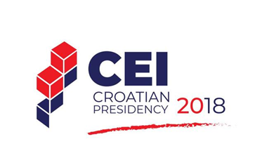
CALENDAR OF EVENTS
(As of 24 October 2018*)

16 February | Zagreb | Official opening of the 2018 Croatian CEI Presidency 1st CNC Meeting
19 April | London | 2nd CNC Meeting and EBRD Steering Committee Meeting
25 – 26 April | Zagreb | Conference “Knowledge sharing for building stronger partnerships in the process of European integration”  Organized by the MFEA
14 May | Zagreb | CEI PD Parliamentary Committee
25 - 26 May | Zagreb | Third Annual Conference of the Western Balkans Migration Network "A search for that special place under the sun in modern Europe: migration in the twenty first century"
29 May | Zagreb | Conference on Intermodal Transport Development  Organized by the Ministry of Sea, Transport and Infrastructure
30 May | Trieste | 3rd CNC Meeting
6 June | Zagreb | Ministerial Conference and workshops  „Fostering Cohesion and Competitiveness through Regional Cooperation”  Organized by the Ministry of Regional Development and EU Funds
11 June | Split | Annual meeting of CEI Foreign Ministers  Preceded by the 4th CNC Meeting
14 August | Dubrovnik | CEI Concert at Dubrovnik Summer Festival: A recital by Andreas Ottensamer clarinet / Jose Gallardo, piano
26 September | New York | Informal CEI Foreign Ministers Meeting (working breakfast or working lunch) during the United Nations General Assembly
26 – 27 September | Zagreb | Conference “Energy Efficiency in Buildings – for a better tomorrow“  Organized by the Ministry of Construction and Spatial Planning
25 – 26 October | Zadar | Conference “Underwater cultural heritage in Europe today”  Organized by International Centre for Underwater Archaeology
26 October | Zagreb | CEMAN (Central European Music Academies Network) Concert at the Vatroslav Lisinki Concert Hall  Organized by Conservatorio Giuseppe Tartini
14 - 16 November | Mali Lošinj | Expert meeting on Cultural Routes  “The Olive Oil Routes”  Organized by the Ministry of Tourism, in cooperation with the Council of Europe
15 – 16 November | Tirana | South East Europe Media Forum
26 November | Zagreb | CEI PD Parliamentary Assembly
3 – 4  December | Zagreb | CEI Summit  CEI Business Forum  5th CNC Meeting

* Additional meetings and events may be added

